EXNO 4: Implement Classification Model Using KNN and Compute Evaluation Metrics
Aim
To build a K-Nearest Neighbors (KNN) classification model and evaluate its performance using accuracy, confusion matrix, and classification report.
Algorithm
- Import the required libraries: Pandas, train_test_split, KNeighborsClassifier, and evaluation metrics from Scikit-learn.
- Load the dataset from the CSV file data.csv.
- Select the input features Hours_Studied, Attendance, and Assignments and store them in X.
- Select the target variable Result and store it in y.
- Split the dataset into 80% training data and 20% testing data using train_test_split() with random_state=42.
- Create a KNN classifier using KNeighborsClassifier(n_neighbors=3).
- Train the model using model.fit(X_train, y_train).
- Predict the target values for the testing data using model.predict(X_test).
- Calculate and display the model's accuracy using accuracy_score().
- Display the confusion matrix using confusion_matrix() to compare actual and predicted values.
- Generate and display the classification report using classification_report(), including precision, recall, F1-score, and support.

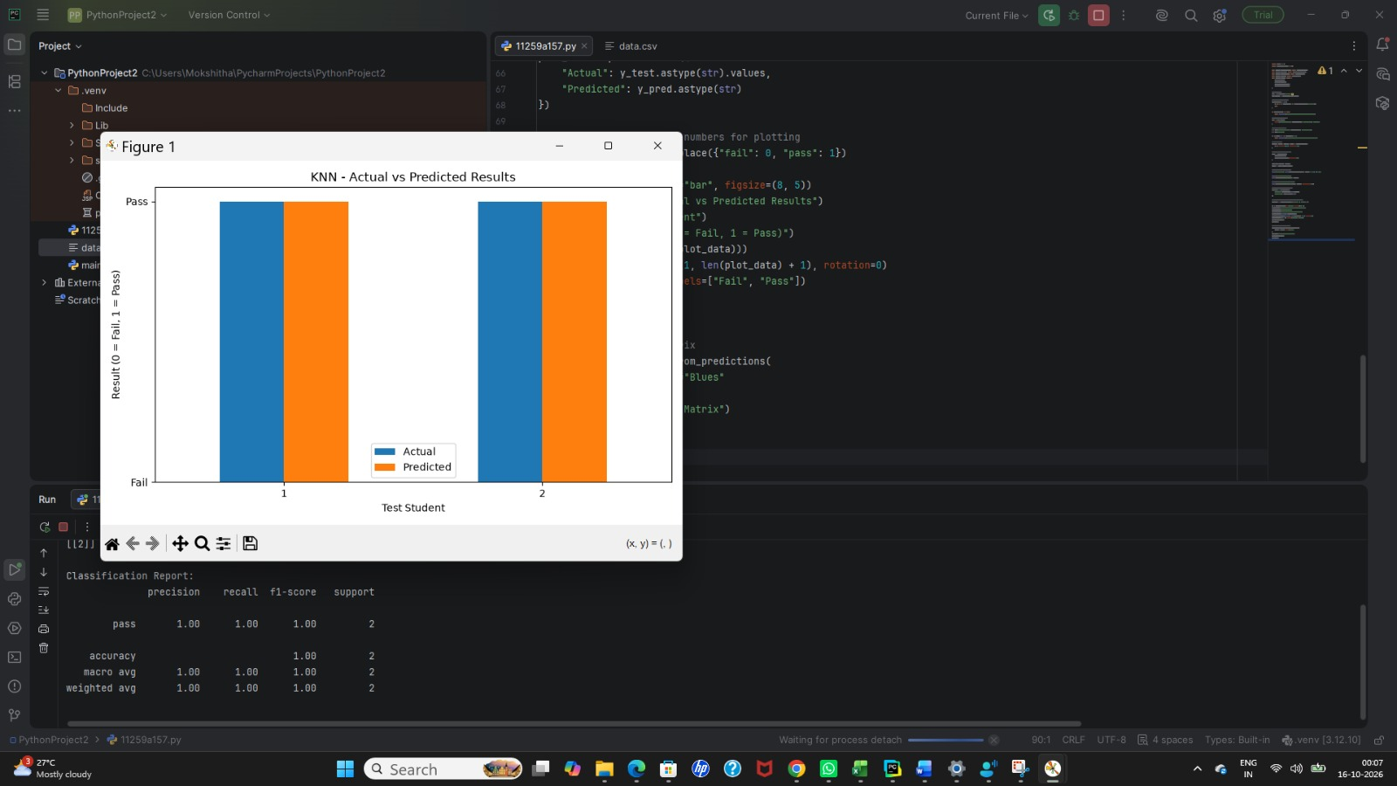

Result
The KNN classification model was successfully trained and used to predict the results for the testing dataset. Its performance was evaluated using the following metrics:
- Accuracy: Measures the proportion of correct predictions.
- Confusion Matrix: Shows the number of correct and incorrect predictions for each class.
- Classification Report: Displays precision, recall, F1-score, and support for each class.

Experiment 4: Implement Classification Model Using SVM and Compute Evaluation Metrics
Aim
To implement a Support Vector Machine (SVM) classification model using a linear kernel and evaluate its performance using accuracy, confusion matrix, and classification report.
Algorithm
- Import the required libraries: Pandas, train_test_split, SVC, and evaluation metrics from Scikit-learn.
- Load the dataset from the CSV file data.csv.
- Select the input features Hours_Studied, Attendance, and Assignments and store them in X.
- Select the target variable Result and store it in y.
- Split the dataset into 80% training data and 20% testing data using train_test_split() with random_state=42.
- Create an SVM classification model using SVC(kernel='linear').
- Train the model using model.fit(X_train, y_train).
- Predict the target values for the testing data using model.predict(X_test).
- Calculate and display the prediction accuracy using accuracy_score().
- Display the confusion matrix using confusion_matrix() to compare actual and predicted classes.
- Generate and display the classification report using classification_report(), which includes precision, recall, F1-score, and support.

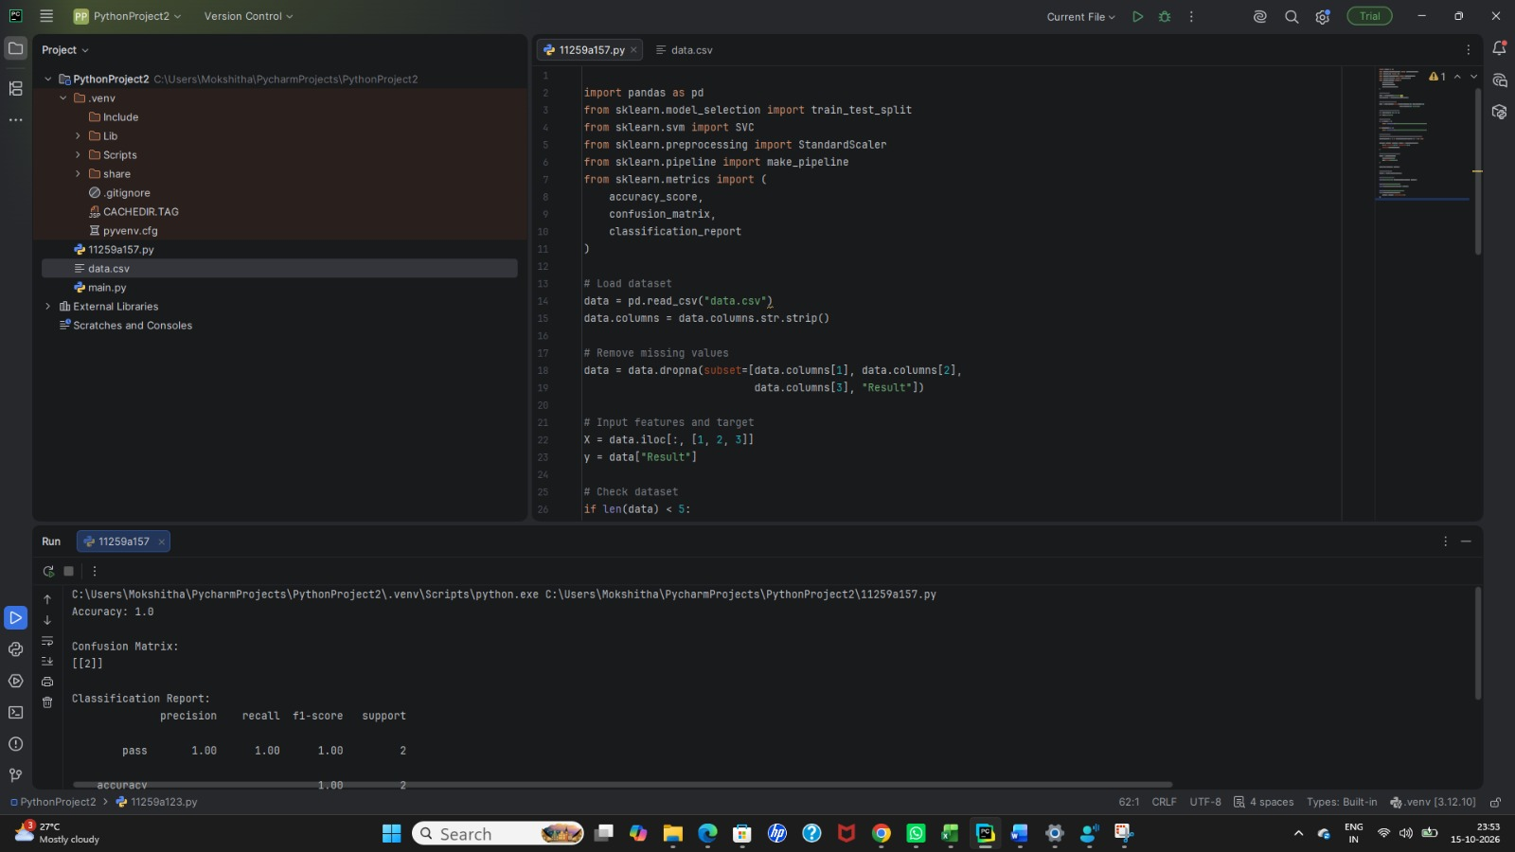

Result
The SVM classification model was successfully trained using a linear kernel and used to predict the results for the testing dataset. The model's performance was evaluated using:
- Accuracy: Measures the proportion of correctly classified samples.
- Confusion Matrix: Shows the correct and incorrect predictions for each class.
- Classification Report: Displays precision, recall, F1-score, and support for each class

